**Start Page of VB.NET IDE**

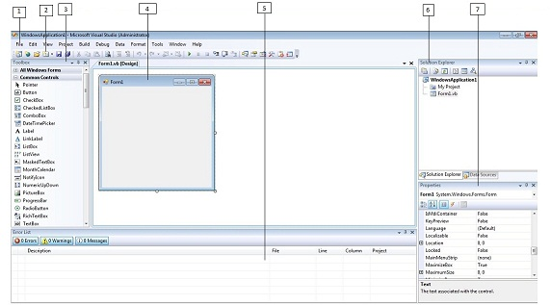

1. Menu Bar

2. Standard Toolbar

3. Toolbox

4. Forms Designer

5. Output Window

6. Solution Explorer

7. Properties Window

**Menu Bar:** Visual Studio .NET’s menu is dynamic, meaning that items will be added or removed depending on what you are trying to do.

File: It seems every windows program has a File Menu. It has become the standard where we should find. In this we find ways of opening and closing single files and whole projects.

Edit: The Edit menu provides access to like Undo, Redo, Cut, Copy, Paste and Delete.

View: The View menu provides quick access to the windows that make up the IDE, such as the Solution Explorer, Properties Window, Output Window, Toolbox etc.

Project: The Project menu allows us to add extra files to our application.

Build: The Build menu becomes important when we have completed our application and want to run it.

Debug: The Debug menu allows us to start and stop running our application. It also gives us access to the Visual Studio.NET debugger. The debugger allows us to step through our code while it is running to see how it is behaving.

Data: The Data menu helps us use information that comes from a database. It only appears when we are working with the visual part of our application not when we are writing code.

Format: The Format menu also only appears when we are working with the visual part of our application. Items on the Format menu allow us to manipulate how the windows we create will appear to the users of our application.

Tools: The Tools menu has commands to configure the Visual Studio .NET IDE, as well as links to other external tools that may have been installed.

Window: The Window menu has become standard for any application that allows more than one window to be open at a time, such as Word or Excel.

Help: The Help menu provides access to the Visual Studio.Net documentation. The Help menu also has options that connect to the Microsoft Web site to obtain updates or report problems.

**Tool Bar:** The toolbar is segmented into groups of related options. The first five icons provide access to the commonly used project and file manipulation options available through the File and Project menus such as opening and saving files.

The next group of icons for editing (Cut, Copy and Paste).

The third group of icons for editing and navigation.

The fourth group of icons provide the ability to start our application running and to specify build configurations.

**Tool box:** the toolbox contains reusable components that can be inserted into our application. These can range from buttons to customized controls.

**Solution Explorer:** The Solution Explorer window contains a hierarchical view of our solution.

**Properties Window:** The Properties window shows what properties the selected object makes available.

**Task List:** The Task List window highlights any errors encountered when we try to run our code. Clicking on the item in this window will take us to the line of code containing the error.

**Output Window:** When we run our code, the progress made in reading it or compiling it is registered via messages posted in the Output window.

**Server Explorer:** The Server Explorer gives us management access to the servers on our network. Here we can create database connections and view services provided by the available servers.